RECORDING REQUESTED BY:
CORINTHIAN TITLE COMPANY, INC.
WHEN RECORDED MAIL TO:
ORDER NO.
ESCROW NO. |  | SPACE ABOVE THIS LINE FOR RECORDER’S USE
POWER OF ATTORNEY - SPECIAL
I/We ___________________________________________ hereby appoint _______________________________, as my/our exclusive, true and lawful attorney-in-fact to act in my/our capacity, for me/us and in my/our name, to dispose of my/our entire ownership interest in that certain real property at _______________________________________________________________, legally described as:
SEE ATTACHED EXHIBIT “A”
Said attorney-in-fact shall have the power to enter into and execute any contract, agreement, note, conveyance, assignment, deed, deed of trust, mortgage, lease, escrow instructions, bank depositor agreement and any and all other instruments or documents as shall be necessary or convenient to buy, sell, exchange, convey, transfer, assign, encumber, hypothecate or lease the above mentioned real property.
THIS POWER OF ATTORNEY shall include the power to mortgage, transfer in trust, or otherwise encumber or hypothecate the real property described above to secure payment on any negotiable or non-negotiable Note or performance of any obligation or agreement in connection with the disposition of the above mentioned property.
I/We, also give and grant onto said attorney-in-fact, full power authority to do and perform all and every act and thing whatsoever requisite, necessary or appropriate to be done in the exercise of the foregoing power in regard to the above mentioned property as fully to all intents and purposes as I/we might or could do if I/we were present, hereby ratifying and confirming all that my/our said attorney shall lawfully do or cause to be done by virtue hereof.
THIS POWER OF ATTORNEY is effective immediately upon the execution hereby and shall remain in full force and effect until and including __________________________ unless sooner terminated by my/our giving written notice of such termination to said attorney-in-fact.

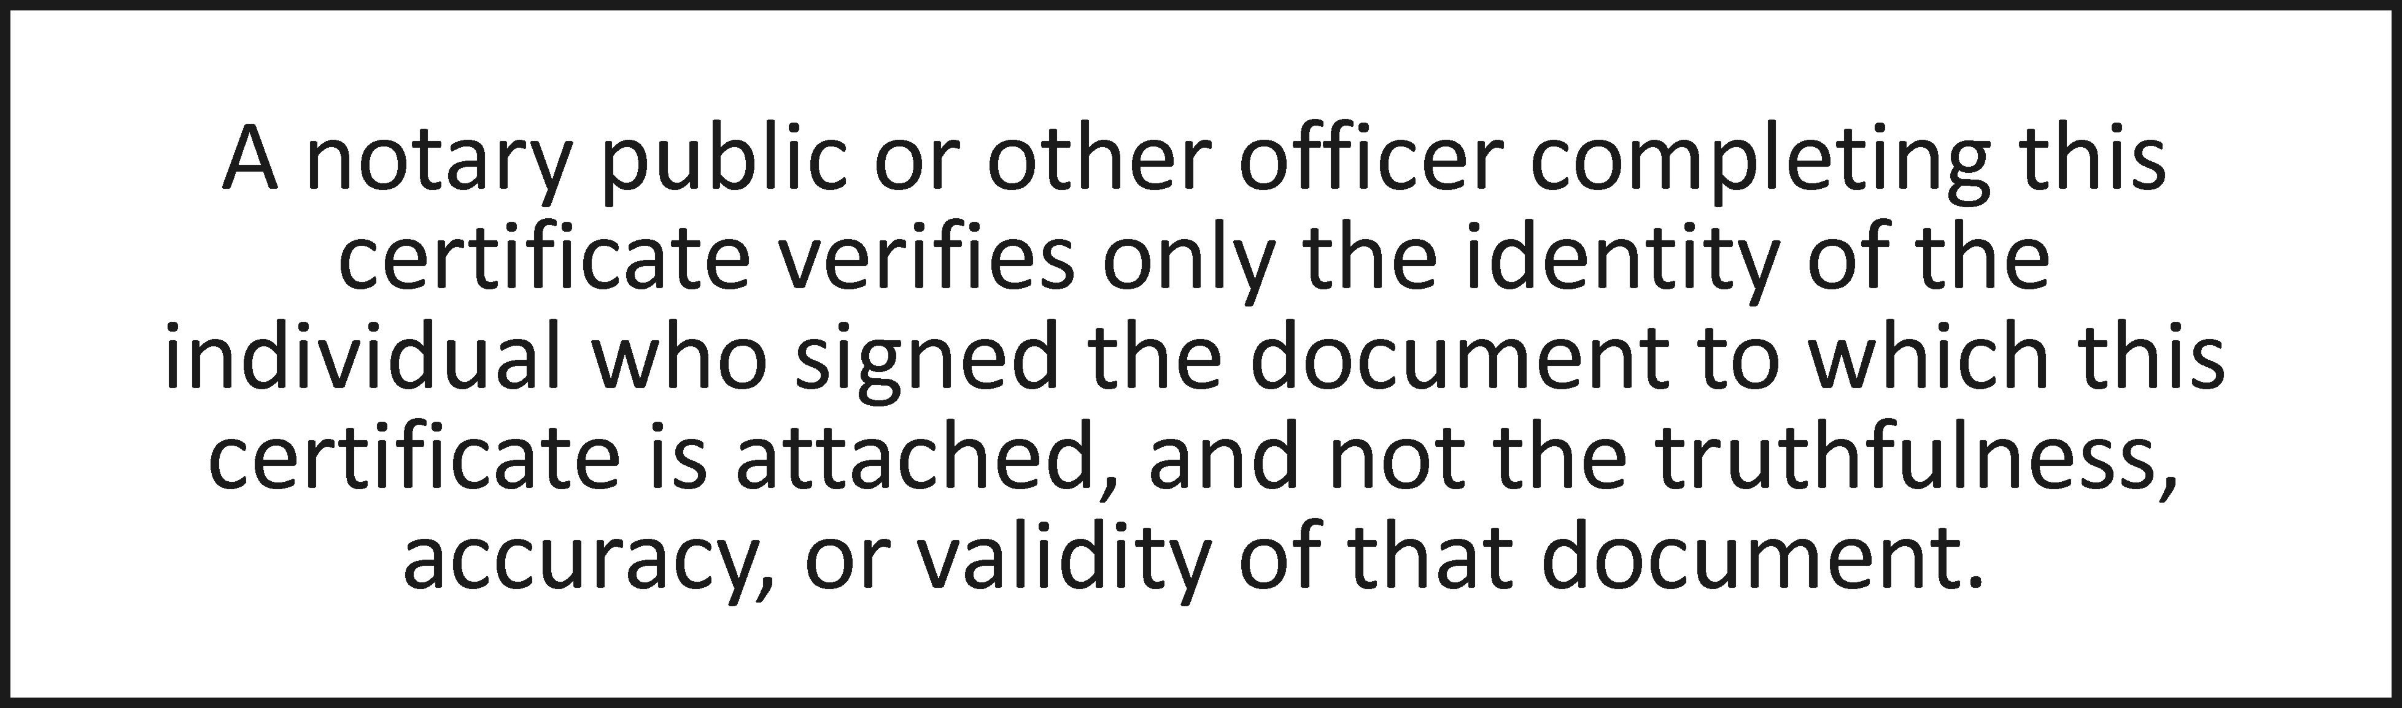
State of California
County of _________________________________________
On __________________before me, Notary Public personally appeared __________________, who proved to me on the basis of satisfactory evidence to be the person(s) whose name(s) is/are subscribed to the within instrument and acknowledged to me that he/she/they executed the same in his/her/their authorized capacity(ies), and that by his/her/their signature(s) on the instrument the person(s), or the entity upon behalf of which the person(s) acted, executed the instrument.
I certify under PENALTY OF PERJURY under the laws of the State of California that the foregoing paragraph is true and correct.
WITNESS my hand and official seal.
Signature ____________________________________________ (Seal)

