RECORDING REQUESTED BY

WHEN RECORDED MAIL TO
AND MAIL TAX STATEMENTS TO

NAME

ADDRESS

CITY
STATE & ZIP

GRANT DEED

TITLE ORDER NO. ESCROW NO. APN NO.

THE UNDERSIGNED GRANTOR(s) DECLARE(s)
DOCUMENTARY TRANSFER TAX is $_____________________________ CITY TAX $______________________________
computed on full value of property conveyed, or computed on full value less value of liens or encumbrances remaining at time of sale,
Unincorporated area: City of __________________________________________________________, and

FOR A VALUABLE CONSIDERATION, receipt of which is hereby acknowledged,

hereby GRANT(s) to

the following described real property in the County of State of California:

Dated__________________________________________ _______________________________________

______________________________________

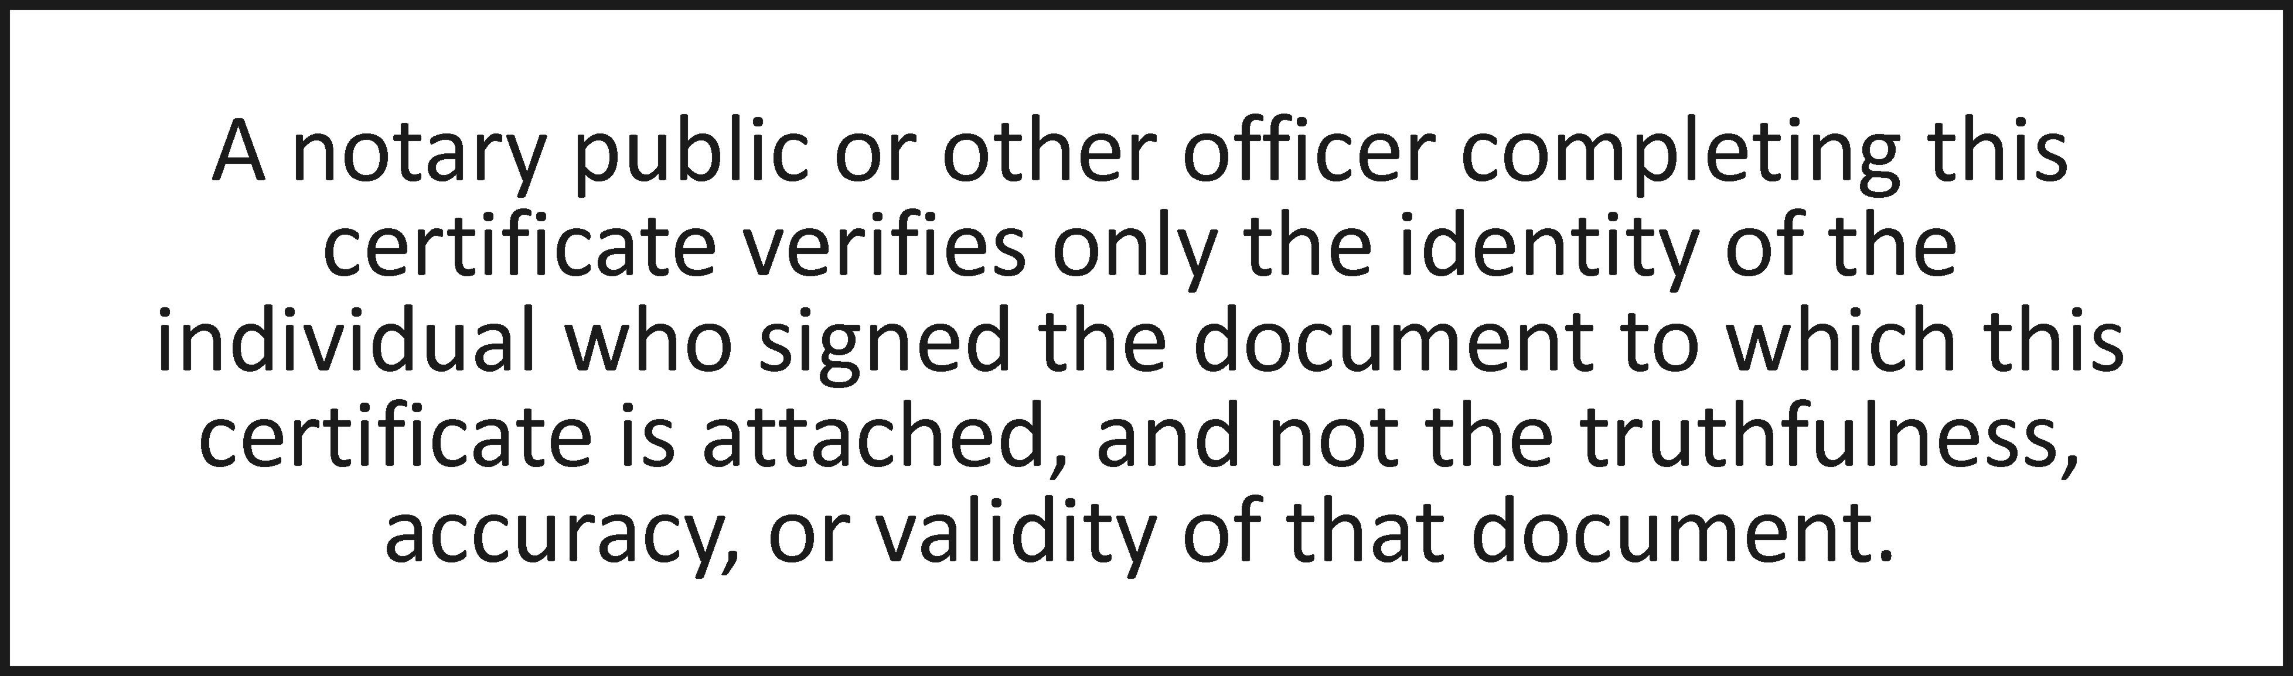

State of California
County of ____________
On __________________before me, Notary Public personally appeared __________________, who proved to me on the basis of satisfactory evidence to be the person(s) whose name(s) is/are subscribed to the within instrument and acknowledged to me that he/she/they executed the same in his/her/their authorized capacity(ies), and that by his/her/their signature(s) on the instrument the person(s), or the entity upon behalf of which the person(s) acted, executed the instrument.
I certify under PENALTY OF PERJURY under the laws of the State of California that the foregoing paragraph is true and correct.
WITNESS my hand and official seal.
Signature ____________________________________________ (Seal)

DOCUMENT PROVIDED BY CORINTHIAN TITLE COMPANY, INC. GRNTDEED.DOC

