RECORDING REQUESTED BY

AND WHEN RECORDED MAIL TO

NAME

ADDRESS

CITY/STATE/ZIP

APN NO.
DECLARATION OF ABANDONMENT
OF DECLARED HOMESTEAD

The undersigned declare(s) that ________ hereby abandon(s) the homestead previously declared in the Homestead
(HE, SHE, THEY)

executed by ____________________________________________________________________________________
(FULL NAME OF DECLARANT(S)

on ___________________________________________, recorded on ______________________________________,

in Book _____________, Page ____________, as Instrument No. ___________________, in the Official Records of the

County Recorder of _________________________________________________________________ County, California.

Dated: _________________________________

________________________________________________ _______________________________________________
(SIGNATURE OF DECLARANT) (SIGNATURE OF DECLARANT)

________________________________________________ _______________________________________________
(PRINT FULL NAME) (PRINT FULL NAME)

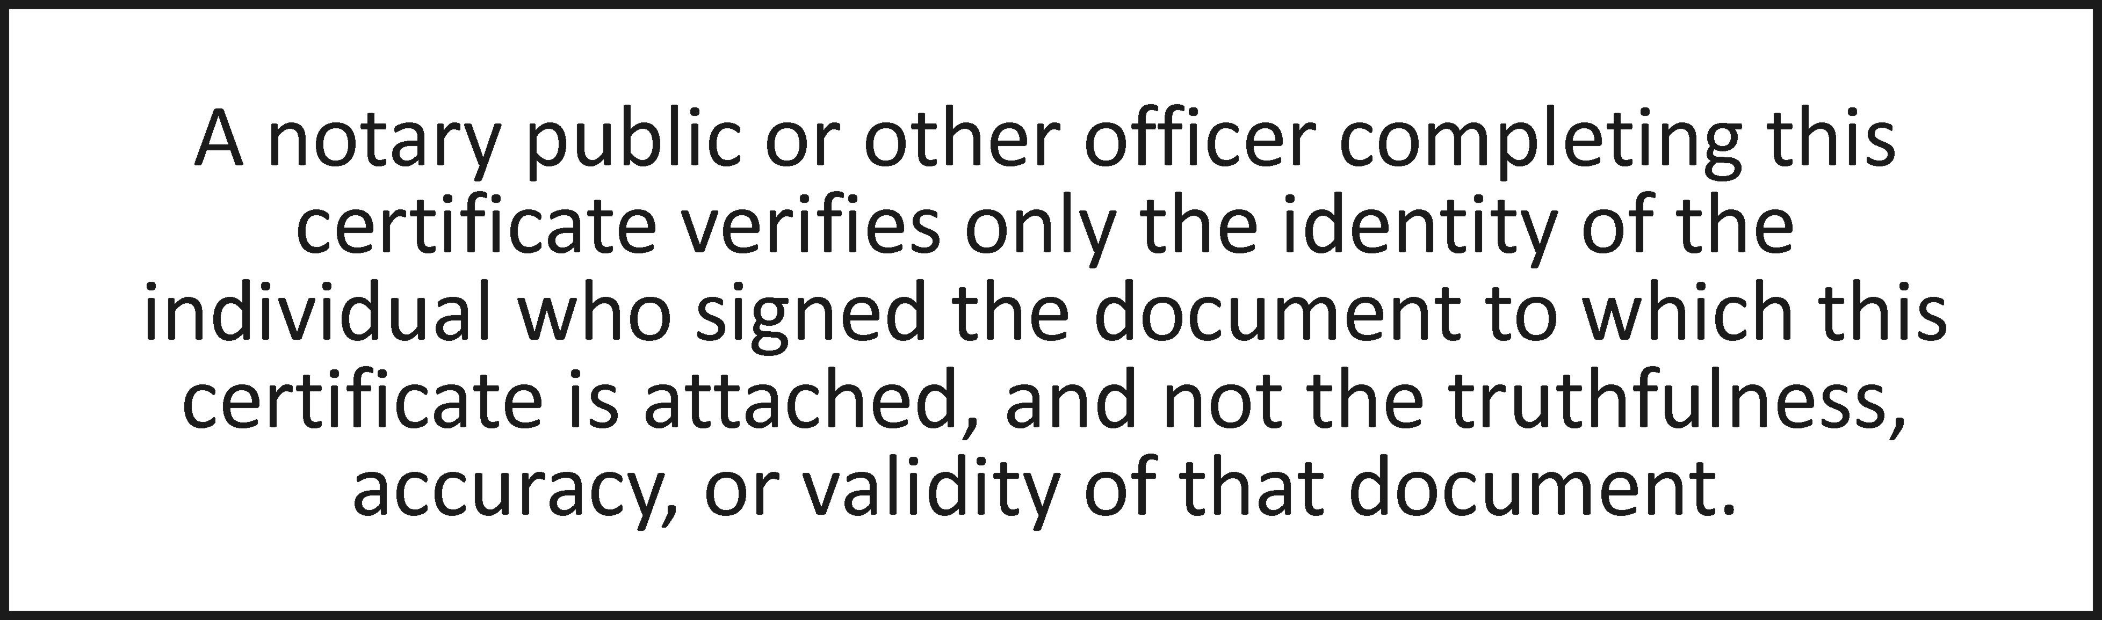

State of California
County of ________________________________
On __________________before me, Notary Public personally appeared __________________, who proved to me on the basis of satisfactory evidence to be the person(s) whose name(s) is/are subscribed to the within instrument and acknowledged to me that he/she/they executed the same in his/her/their authorized capacity(ies), and that by his/her/their signature(s) on the instrument the person(s), or the entity upon behalf of which the person(s) acted, executed the instrument.
I certify under PENALTY OF PERJURY under the laws of the State of California that the foregoing paragraph is true and correct.
WITNESS my hand and official seal.

Signature ____________________________________________ (Seal)

DOCUMENT PROVIDED BY CORINTHIAN TITLE COMPANY, INC. DEABHOME.DOC

