RECORDING REQUESTED BY

AND WHEN RECORDED MAIL TO

NAME

ADDRESS

CITY
STATE & ZIP

TITLE ORDER NO ESCROW NO. APN NO.
AFFIDAVIT OF DEATH OF SPOUSE
(COMMUNITY PROPERTY WITH RIGHT OF SURVIVORSHIP)

STATE OF CALIFORNIA
COUNTY OF ______________________________} SS.

___________________________________________________________ , of legal age, being first duly sworn, deposes and says: That ________________________________________________________, the decedent mentioned in the attached certified copy of Certificate of Death, is the same person as ___________________________________________________________________named as one of the parties in that certain ____________________________________ dated ______________________________, executed by ________________________________________________________________________________________________,
to ________________________________________________________________________________________________________,
as Community Property with Right of Survivorship, recorded as Instrument No. ______________________ on __________________,
in Book _________, Page ________, of Official Records of _______________________________________County, California, covering the following described property situated in the said County, State of California

__________________________________________________

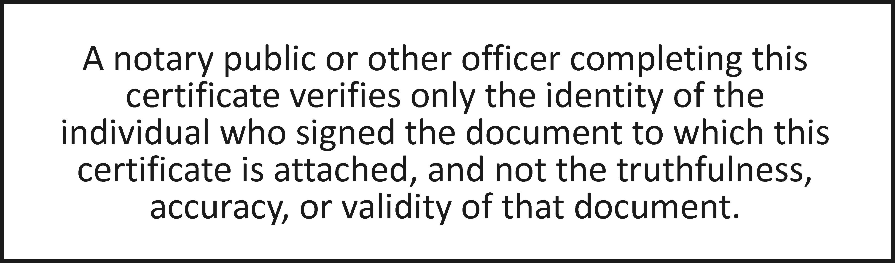

State of California
County of ____________________
Subscribed and sworn to (or affirmed) before me, _____________________________________ Notary Public on this____day of _____, 20___, by ________________________, proved to me on the basis of satisfactory evidence to be the person(s) who appeared before me.
Signature ________________________ Seal

DOCUMENT PROVIDED BY CORINTHIAN TITLE COMPANY INC. AFFDEATHSPOUSE.DOC

